Shashank Thakare

Assignment 12 July 2019

Q1. what is component Diagram ?

A. Component diagrams are different in terms of nature and behavior. Component diagrams are used to model the physical aspects of a system. Component diagram is a special kind of diagram in UML. The purpose is also different from all other diagrams discussed so far. It does not describe the functionality of the system but it describes the components used to make those functionalities.

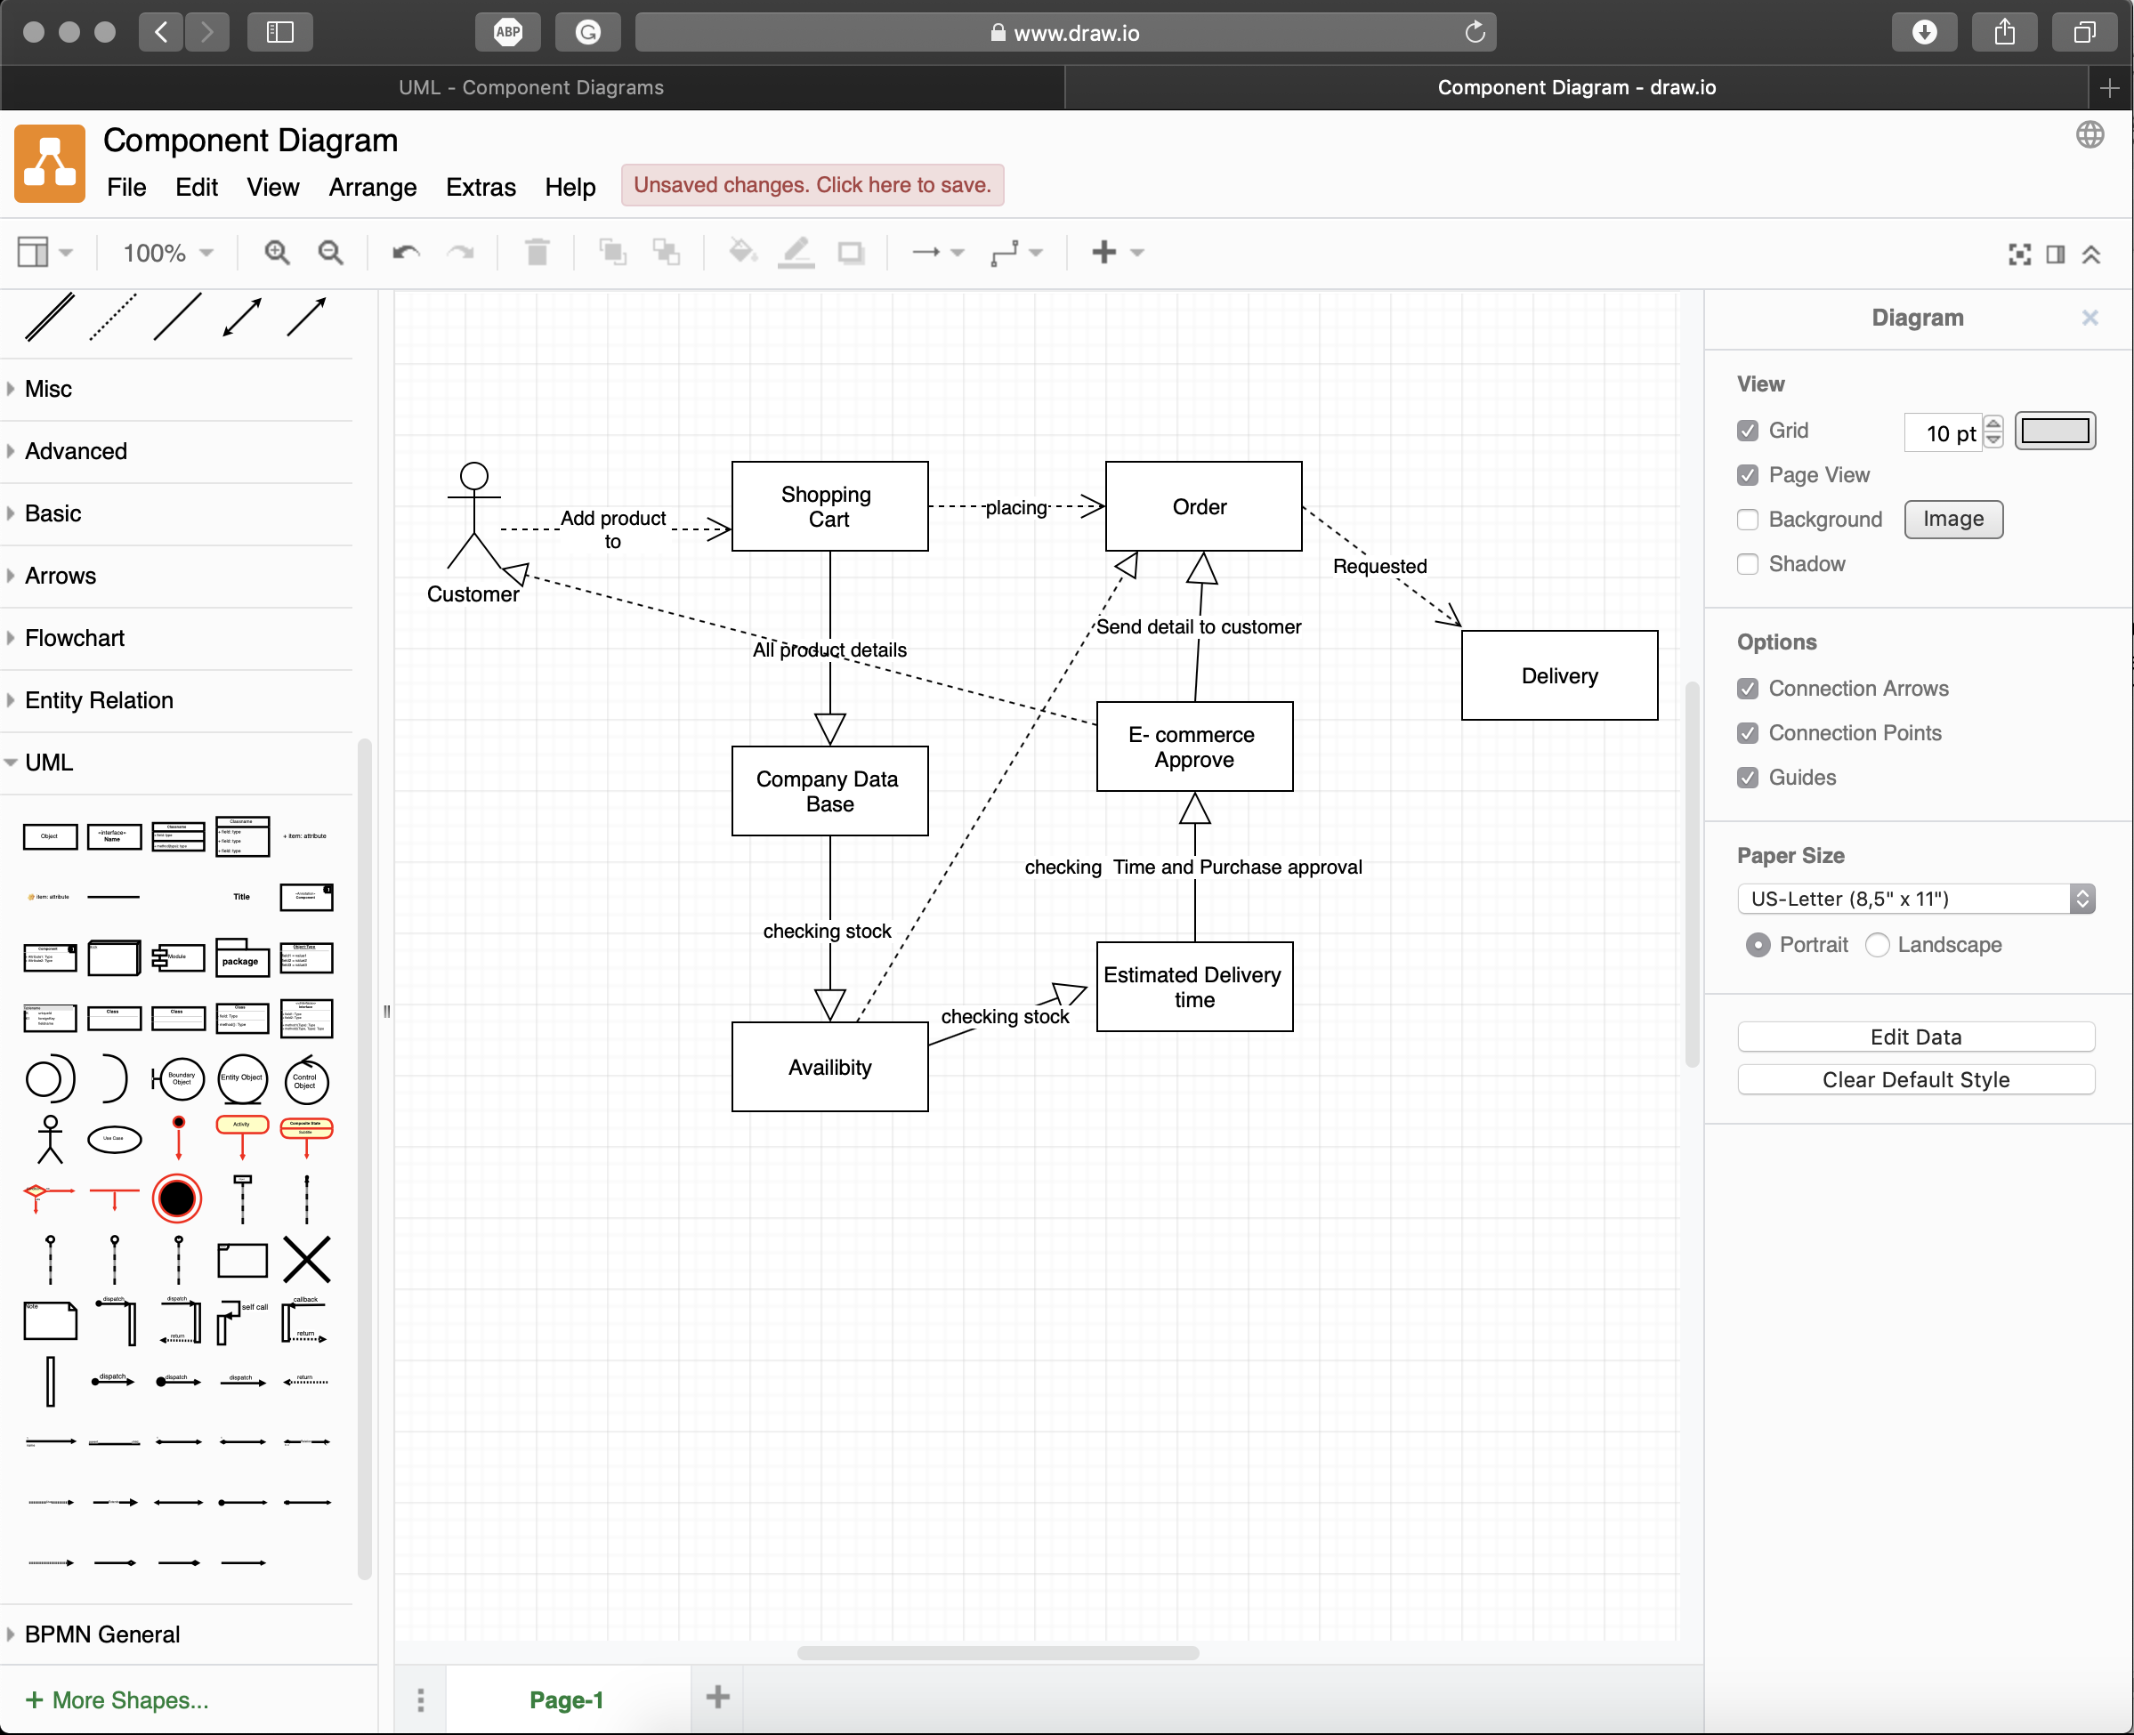

Q2. what is Object diagram?

A.Object diagrams are derived from class diagrams so object diagrams are dependent upon class diagrams.

Object diagrams represent an instance of a class diagram. The basic concepts are similar for class diagrams and object diagrams. The purpose of a diagram should be understood clearly to implement it practically. The purposes of object diagrams are similar to class diagrams.

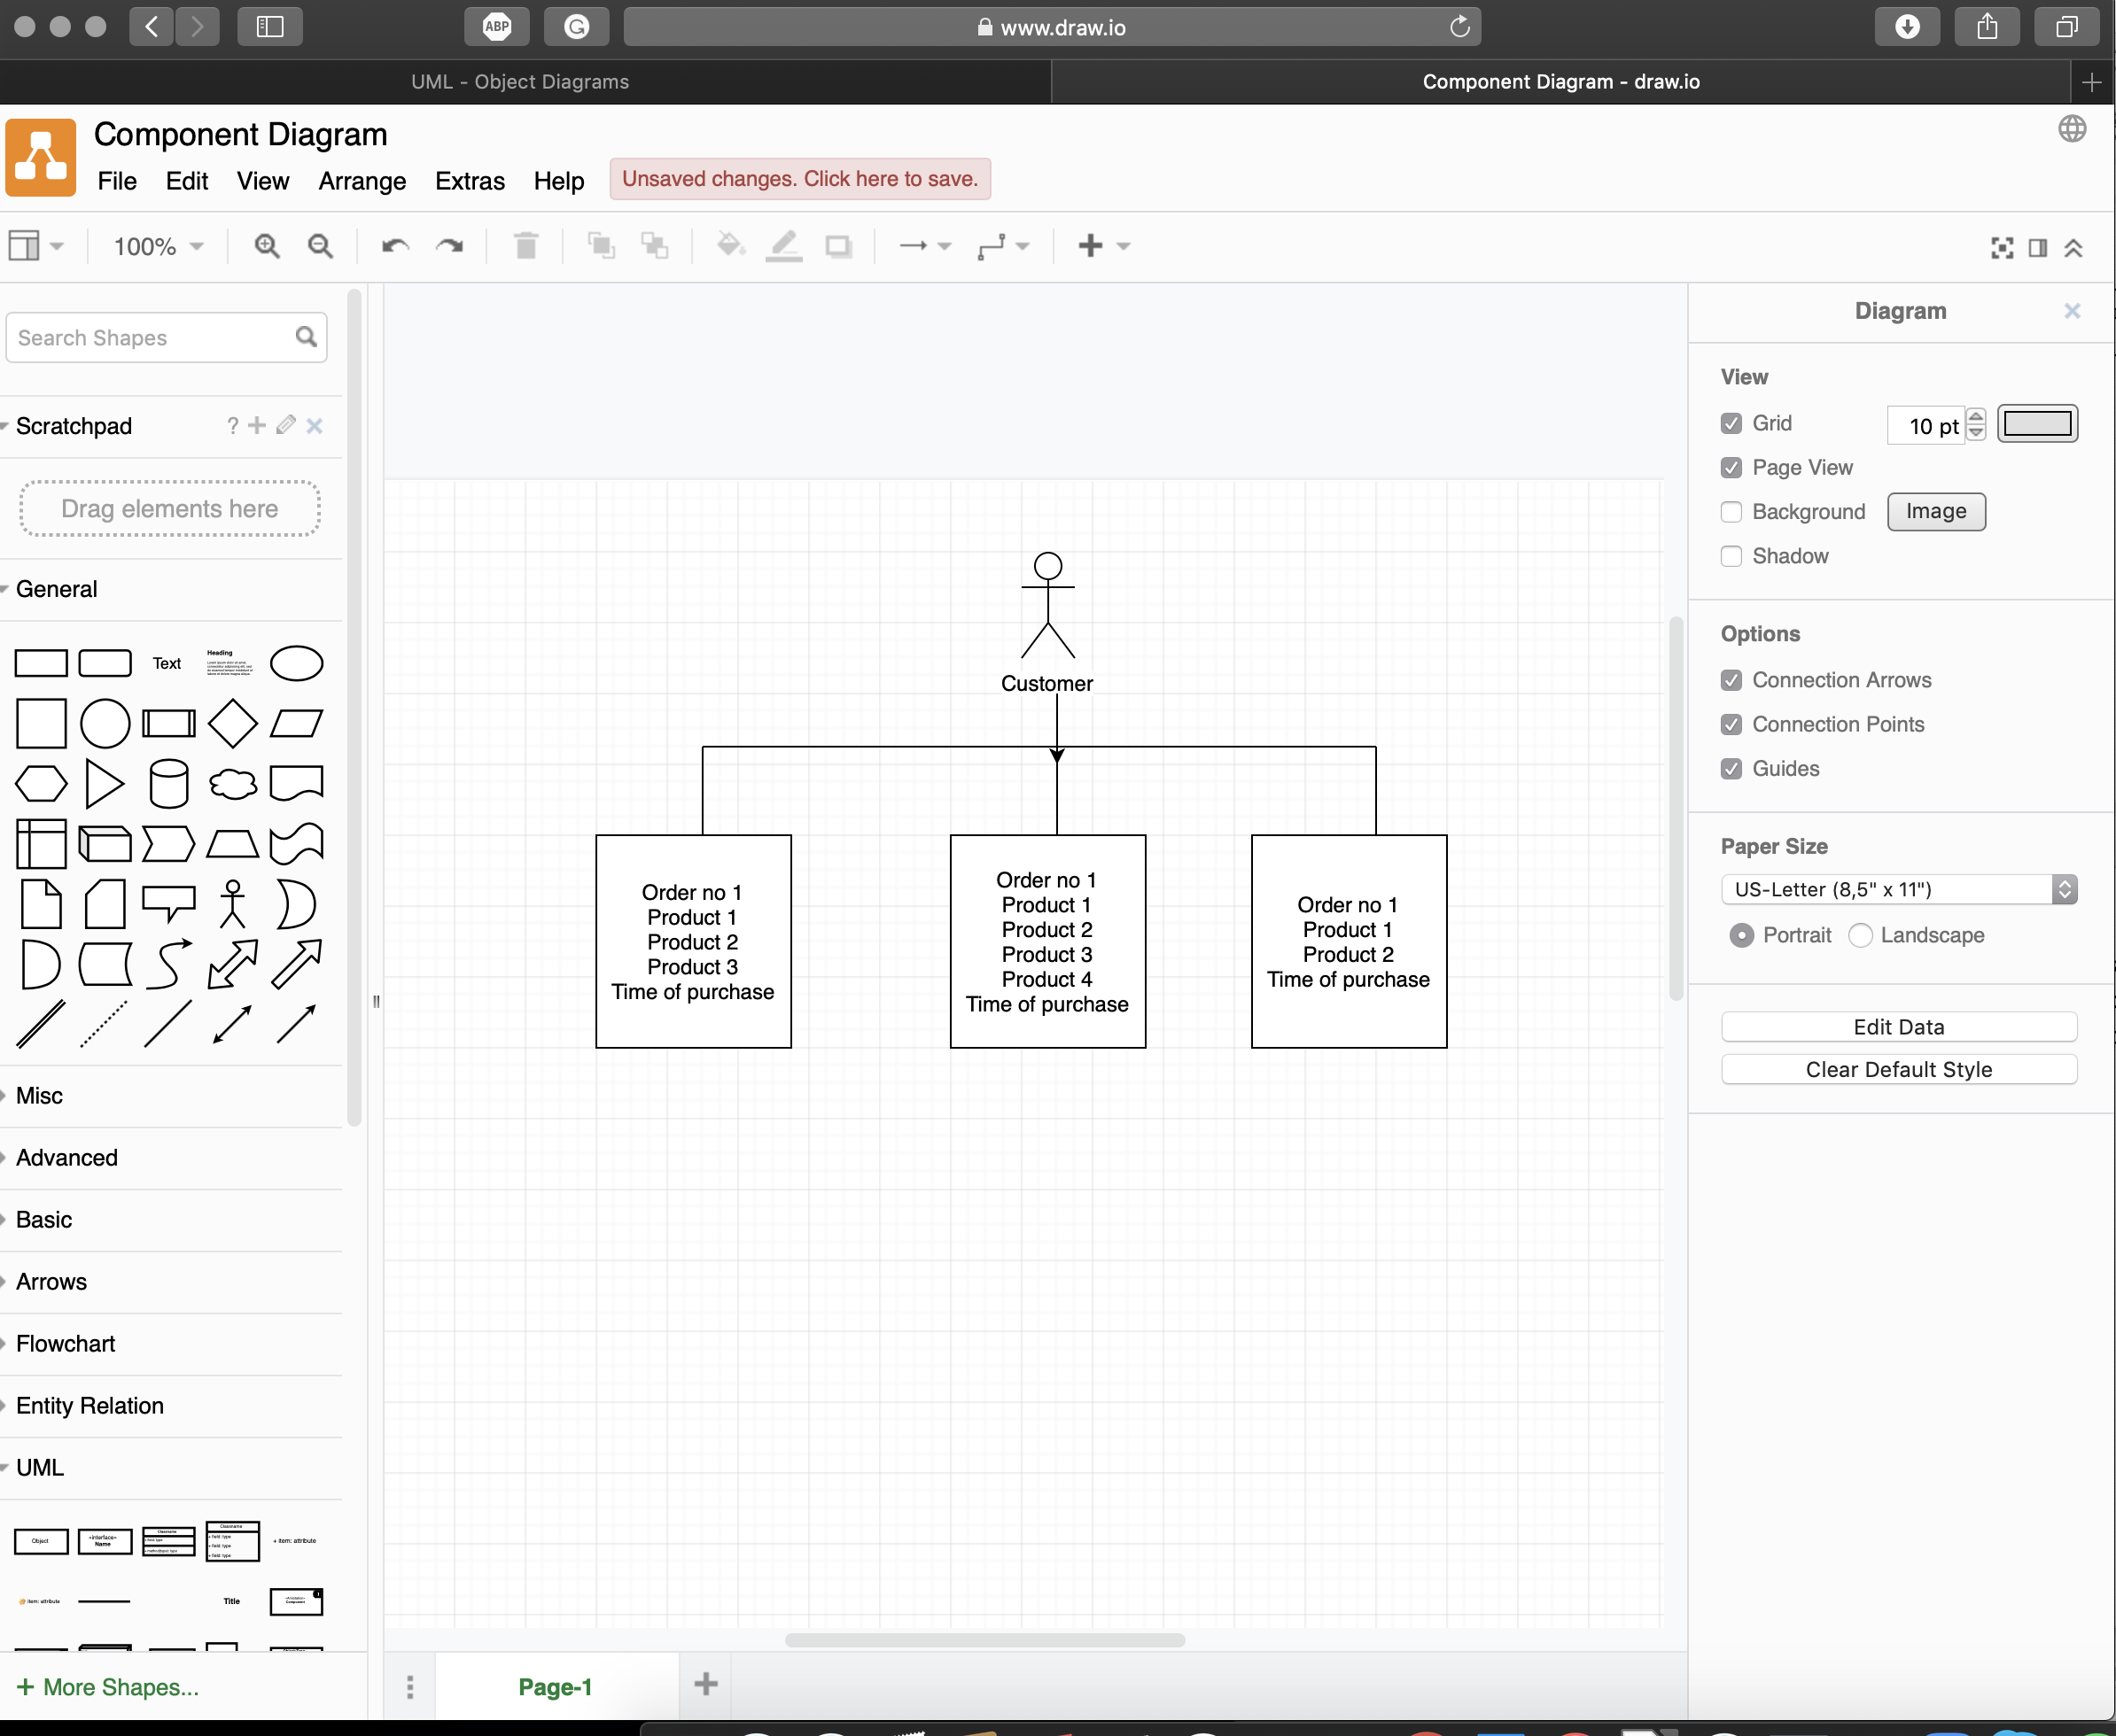

Q3. what is deployment Diagram?

A. Deployment diagrams are used to visualize the topology of the physical components of a system, where the software components are deployed. Deployment diagrams are used to describe the static deployment view of a system. Deployment diagrams consist of nodes and their relationships. Component diagrams are used to describe the components and deployment diagrams shows how they are deployed in hardware.

